Private Class is a one-on-one learning session between a teacher and a student. In this type of class, the teacher focuses on a single student, allowing the learning process to be more personalized and tailored to the student’s needs, level, and learning goals.
In a Private Class, students can book a schedule based on the teacher’s availability. The system will match the student’s selected level with teachers who are qualified to teach that level. Once the schedule is confirmed, the student and teacher will join the session at the scheduled time.
Private Classes can be conducted online or offline, depending on the class configuration. During the session, the teacher will guide the student through the learning materials, provide explanations, and help the student practice the skills being taught.
This type of class allows for more direct interaction, personalized feedback, and flexible learning, making it suitable for students who want focused guidance and a customized learning experience.
To try testing Student Private please following step below.
Open Schedule in Squadmin
- Admin opens the class through the Admin Dashboard:
https://legacy-staging.cakap.com/dashboard/squadmin2013/en/login
- Go to the Calendar menu, then make sure the Study selected is correct (for example: English) before creating or managing the class schedule.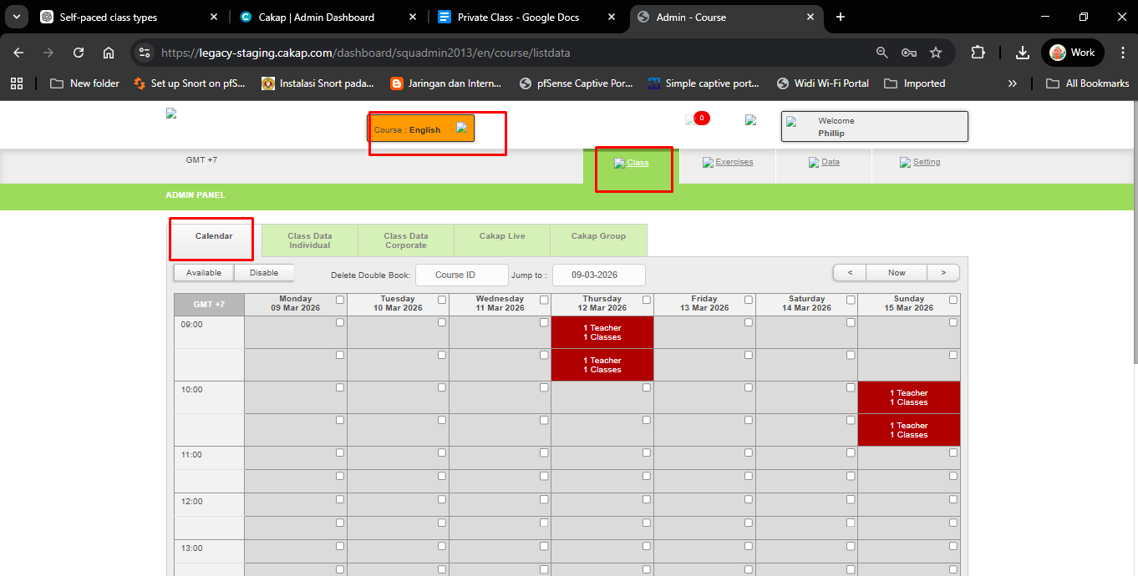
- Click the checkbox on the schedule you want to open, then click “Available” to make the schedule available for booking.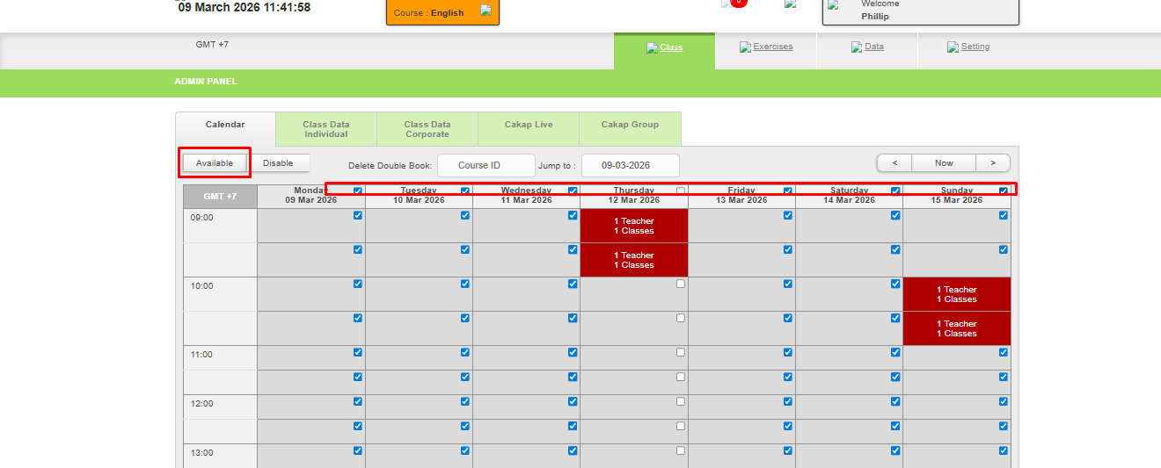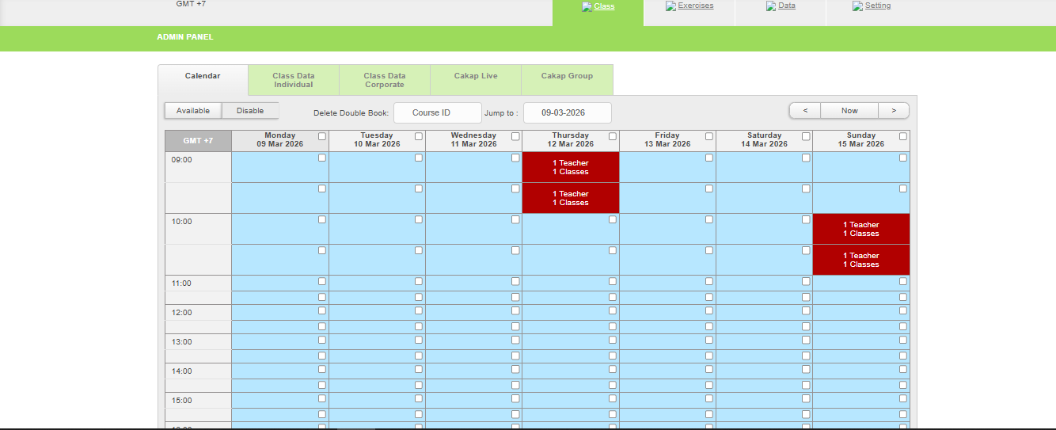
- After the schedule has been opened, the Squadmin needs to open the class for the teacher.

Open Schedule in Teacher
- Login in https://teacher-staging.cakap.com/login use 1 sample account teacher in study has been opened
- Go to the Calendar menu. Click the checkbox on the schedule you want to open, then click “Open Class from Selected Checkbox.” A popup with the level list will appear. Select the level that matches the student’s level so the student can book the teacher. After that, click “Open Class.” The class will be successfully opened and available for students to book.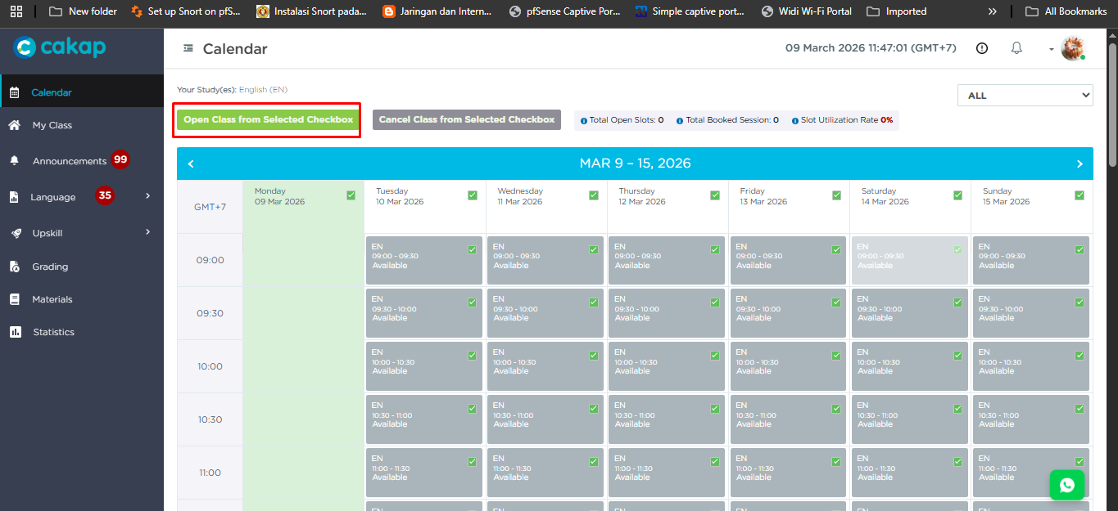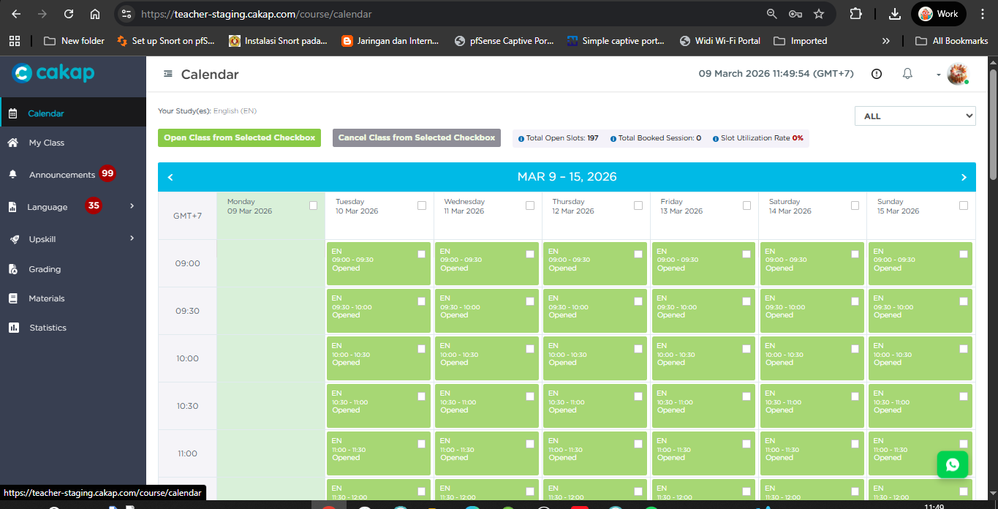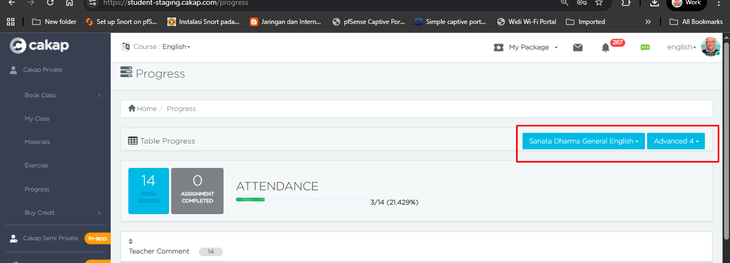
- This is a case remark or flag indicating that the teacher has already been booked by a student.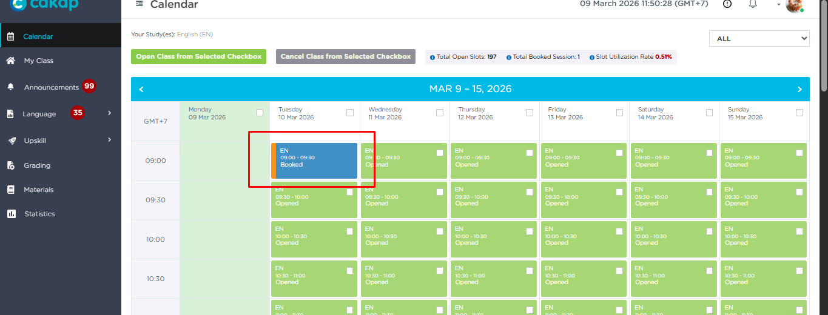
Student Booked Teacher
- Students need to purchase a package first. Go to the Buy Credit -> Course menu and select one of the available packages:
https://student-staging.cakap.com/package. Choose the preferred payment method and complete the payment process. After the payment is successful, the package will be activated and available for the student to use.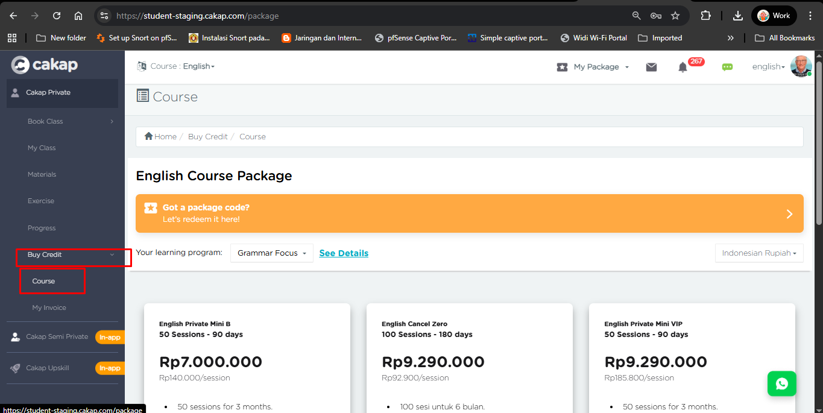
- Go to the Calendar menu:
https://student-staging.cakap.com/course/calendar. Choose the available schedule, select the teacher, choose the time, then click “Book Now.” After the booking is successful, the schedule will be reserved for the student.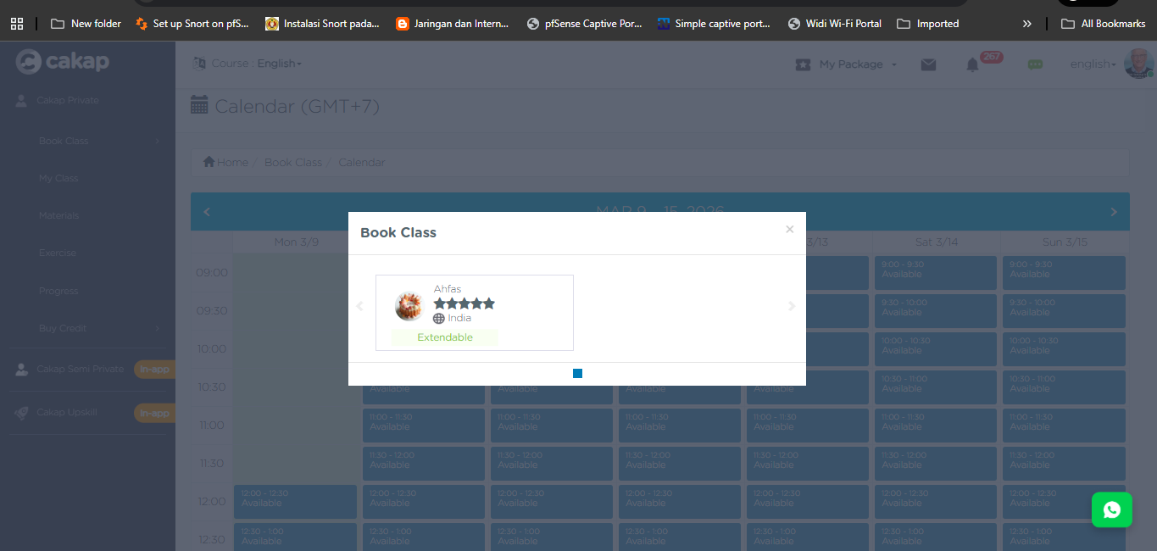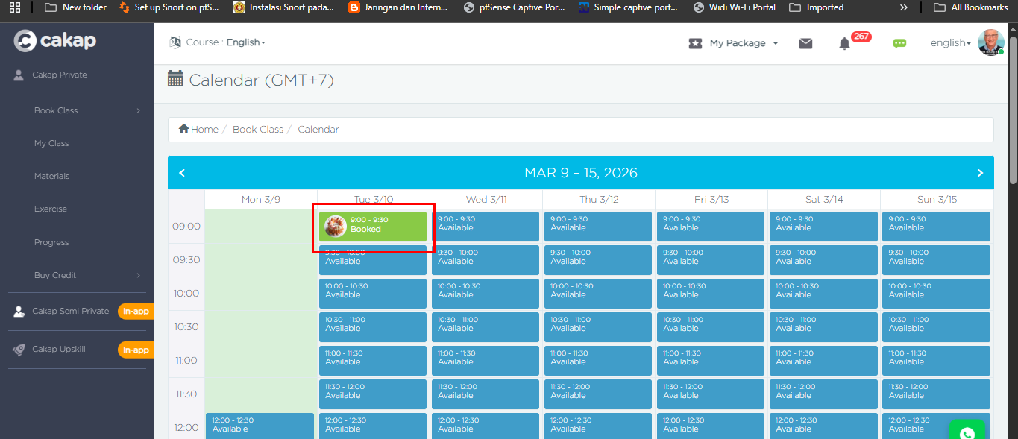
- When the class is live, both the student and the teacher can join the class using the provided Google Meet link. They can enter the class one by one through the link at the scheduled time.
- After the class is over, a Daily Report will be generated on the teacher’s dashboard. The teacher can then review and submit the report through the dashboard.